**Prediction of Compressive Strength of Concrete**

**1 INTRODUCTION**

**1.1 Overview**

Concrete is a material used in construction that has great versatility and which is used across the globe. Concrete has several advantages, including good compressive strength, durability, workability, construction availability, and low cost. Determining accurate concrete strength is a major civil engineering problem. The traditional way to know the strength of concrete will take about 28 days which is very time-consuming. It is important to wait 28 days to ensure the quality control of the process, although it is very time-consuming. This project aims at building a Machine Learning model to predict the compressive strength of concrete to greatly speed up prediction with higher accuracy. A web application is built where the user can enter the required parameters and see the predicted results on Web Application.

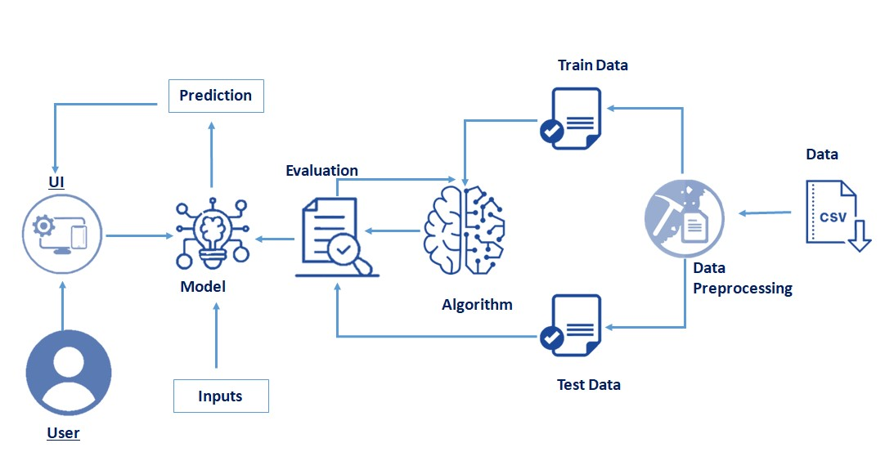

**1.2 Purpose**

The Compressive Strength of Concrete determines the quality of Concrete. This is generally determined by a standard crushing test on a concrete cylinder. This requires engineers to build small concrete cylinders with different combinations of raw materials and test these cylinders for strength variations with a change in each raw material. The recommended wait time for testing the cylinder is 28 days to ensure correct results. This consumes a lot of time and requires a lot of labour to prepare different prototypes and test them. Also, this method is prone to human error and one small mistake can cause the wait time to drastically increase.

One way of reducing the wait time and reducing the number of combinations to try is to make use of digital simulations, where we can provide information to the computer about what we know and the computer tries different combinations to predict the compressive strength. This way we can reduce the number of combinations we can try physically and reduce the amount of time for experimentation. But, to design such software we have to know the relations between all the raw materials and how one material affects the strength. It is possible to derive mathematical equations and run simulations based on these equations, but we cannot expect the relations to be same in real-world. Also, these tests have been performed for many numbers of times now and we have enough real-world data that can be used for predictive modelling.

**2 LITERATURE SURVEY**

**2.1 Existing problem**

The ANN model needs a lot of parameters, and the learning process is like a black box. Hence, it is difficult to carry out the actual derivation step by step, affecting the credibility. In addition, in the learning process, it is easy to appear over-fitting state; therefore, some researchers used GA to optimize the internal structure parameters of the neural network. Although GA is a solution for optimizing the neural network, its programming process is complex and the search speed is slow. Therefore, another new model, XGBoost, will be introduced later.

**2.2 Proposed solution**

The extreme gradient boosting (XGBoost) is a novel machine learning algorithm mainly used for supporting classification, regression, and ranking. In recent years, it has gradually attracted attention owing to its excellent performance of strong learning ability and fast convergence during parallel learning computations shown in many AI competitions. In KDDCup competition including commercial sales forecast, the team of Top 10 used the XGBoost algorithm for web page text classification, customer behaviour prediction, ad click rate prediction, and hazard risk prediction and other fields.

**3 THEORITICAL ANALYSIS**

**3.1 Block Diagram**

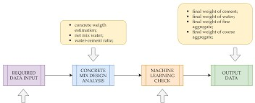

**3.2 Hardware / Software designing**

1. Hardware requirements

* Processor – i5
* RAM – 8GB

1. Software requirements

* Anaconda3
* Jupyter Notebook
* Browsers

**4 EXPERIMENTAL INVESTIGATIONS**

For the purpose of selecting the most suitable prediction model for HPCS, this paper uses the comparative experimental method. Specific concrete samples are prepared in the laboratory, and the data are preprocessed after understanding the characteristics of each data, so as to select the model with the best prediction performance based on machine learning theory.

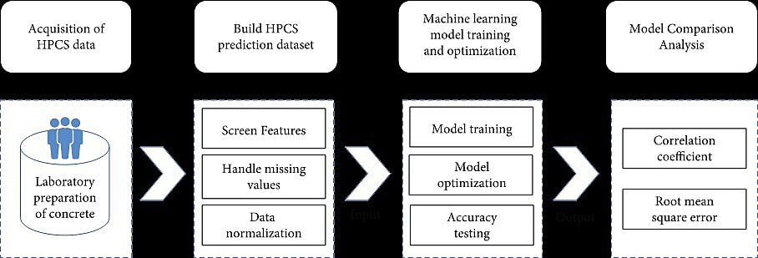

In order to compare and analyse the performance of three machine learning methods, RF, SVR, and XGBoost, on the concrete compressive strength dataset, this paper selects R2 and RMSE from the commonly used machine learning evaluation metrics. Where the root mean square error (RMSE) mainly measures the accuracy of the model, the smaller its value, the higher the prediction accuracy of the model. The correlation coefficient (R2) characterizes the closeness between the predicted value of the model and the true value of the data, and the closer the R2 is to 1, the higher the prediction accuracy of the model.

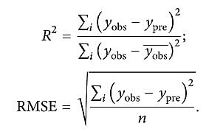

**5 FLOWCHART**

Dataset

Data Preprocessing

Training Data

Testing Data

Model Evaluation

Prediction

**6 RESULT**



fig:Home Page



**Entering the values**



**Output:**

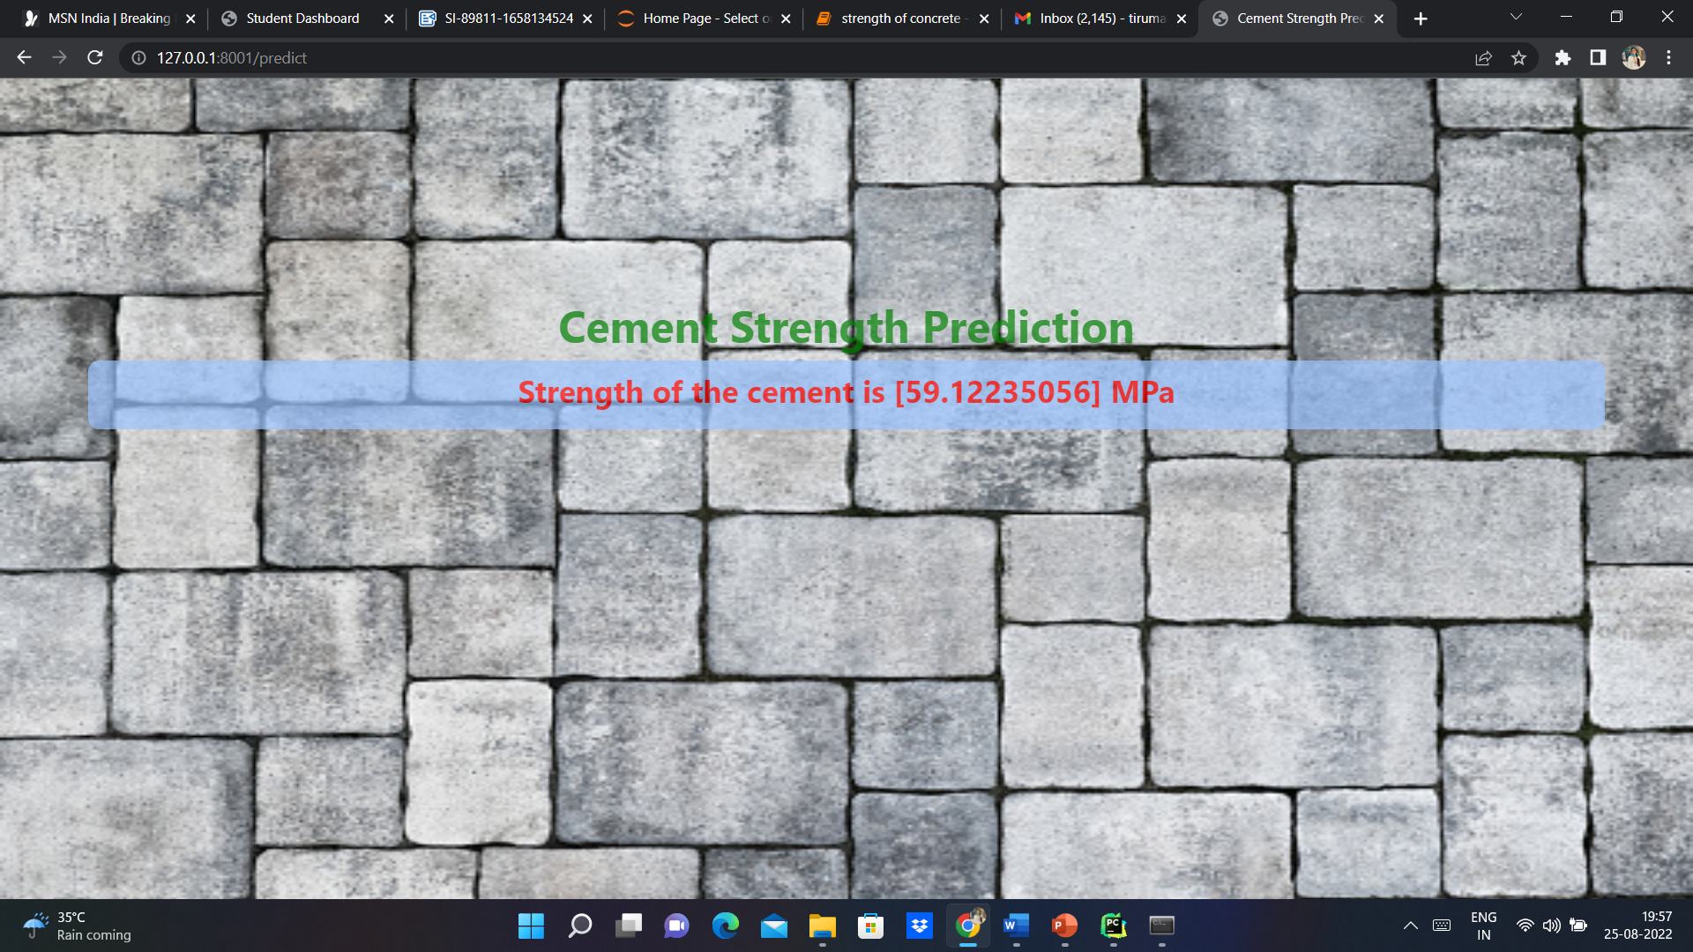

**7 ADVANTAGES & DISADVANTAGES**

**7.1 Advantages**

* Often provides predictive accuracy that cannot be trumped.
* Lots of flexibility - can optimize on different loss functions and provides several hyper parameter tuning options that make the function fit very flexible.
* No data pre-processing required - often works great with categorical and numerical values as is.
* Handles missing data - imputation not required.

**7.2 Disadvantages**

* Gradient Boosting Models will continue improving to minimize all errors. This can overemphasize outliers and cause over-fitting.
* Computationally expensive - often require many trees (>1000) which can be time and memory exhaustive.
* The high flexibility results in many parameters that interact and influence heavily the behaviour of the approach (number of iterations, tree depth, regularization parameters, etc.). This requires a large grid search during tuning.
* Less interpretative in nature, although this is easily addressed with various tools.

**8 APPLICATIONS**

At present, the design and development of application software based on various prediction models is receiving increasing attention. This behaviour can encourage to develop software from theory to practical application. Therefore, in this study, C# programming was utilized for integrating the involved research results and methods into an application software (named PSCS V1.0) with straightforward interactive interfaces to help users without the knowledge of MATLAB to predict and analyse easily and efficiently. With the help of PSCS, users can just input the dimension of sample (unifying the compressive strength of concrete under different dimensions automatically) and main parameters (the parameters obtained by GRA, i.e., type of cement, W/B ratio, sand ratio, slag content, MK content, dosage of water-reducing agent, and curing age).

**9 CONCLUSION**

We have analysed the Compressive Strength Data and used Machine Learning to Predict the Compressive Strength of Concrete. We have used Gradient Boosting where we got RMSE score a 5.6. Also, we can further improve the performance of the algorithm by tuning the hyper parameters by performing a grid search or random search.

**10 FUTURE SCOPE**

Developing a mobile app is more convenient for alerting the people to predict the strength of concrete the app is accessible through phones. Giving suggestions for people fast based on qualities how to maintain strength for the surveillance of quality.

**11 BIBILOGRAPY**

1. I-Cheng Yeh, “ [Modelling of strength of high performance concrete using artificial neural networks](https://www.sciencedirect.com/science/article/abs/pii/S0008884698001653),” Cement and Concrete Research, Vol. 28, №12, pp. 1797–1808 (1998).
2. Ahsanul Kabir, Md Monjurul Hasan, Khasro Miah, “ [Strength Prediction Model for Concrete](https://www.researchgate.net/publication/258255660_Strength_Prediction_Model_for_Concrete)”, ACEE Int. J. on Civil and Environmental Engineering, Vol. 2, №1, Aug 2013.

<https://archive.ics.uci.edu/ml/datasets/Concrete+Compressive+Strength>

**Appendix**

